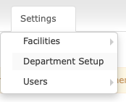
Below is a screen shot of Mount Sinai’s Department Set by Facility. We have 17 facilities here. Some clients may have 1, some may have more than 17 facilities. *NOTE* MD Buyline requires Mount Sinai to amend the contract when adding/removing facilities. Therefore, we do not offer access to add/remove facilities. That will have to be done by our team internally.
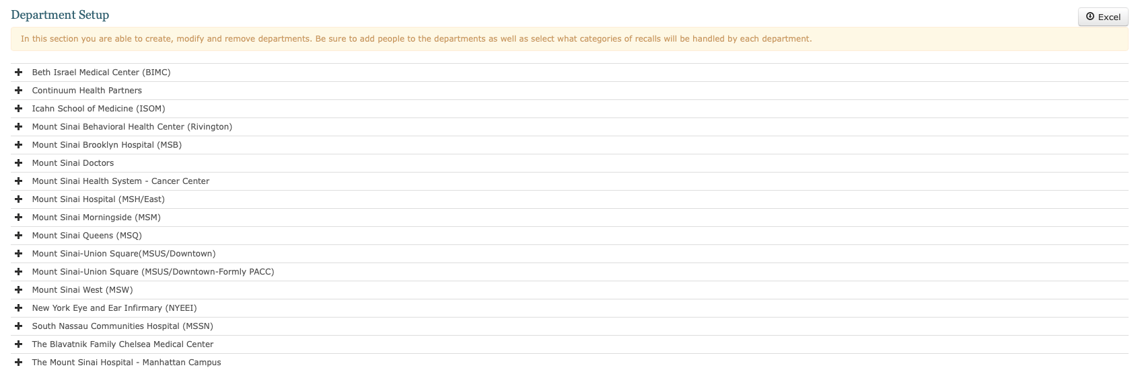
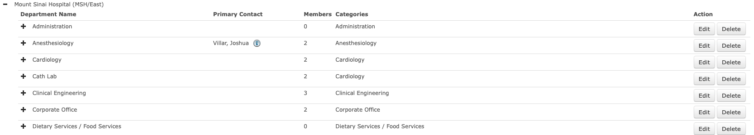

Link below to my sharepoint Department Data import sheet. We have 36 canned department fields, and need the ability to add new departments/ delete departments. I can also edit the names of each department.
https://netorgft3020338.sharepoint.com/:x:/r/sites/TotalRecall/_layouts/15/Doc.aspx?sourcedoc=%7BC3F09575-E294-4614-A2C1-19B287E9AACC%7D&file=Department%20Setup%20Template.xlsx&action=default&mobileredirect=true

When I click on a department, such as “Sterile Processing” it expands to show you who the contacts are.
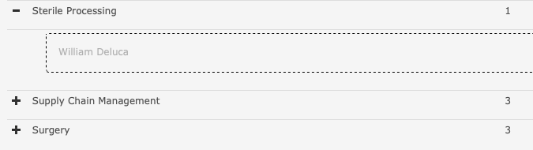
Then if I click in the box where “William Deluca” is, another department window opens where I can add new end users to a department using a pick list. I can remove William here, or add several more contacts. Hit save and its updated.
